1. Unable to edit the invoice record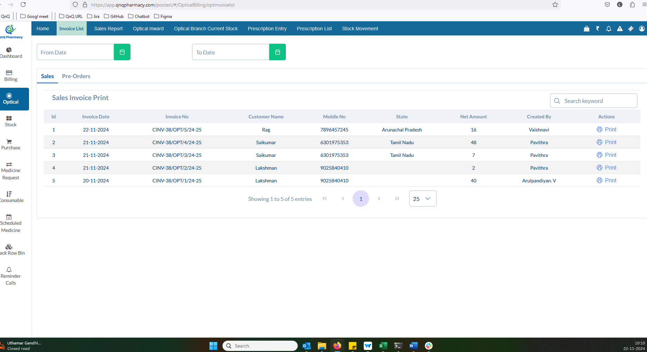//
2. Screen Title not display while navigate the page 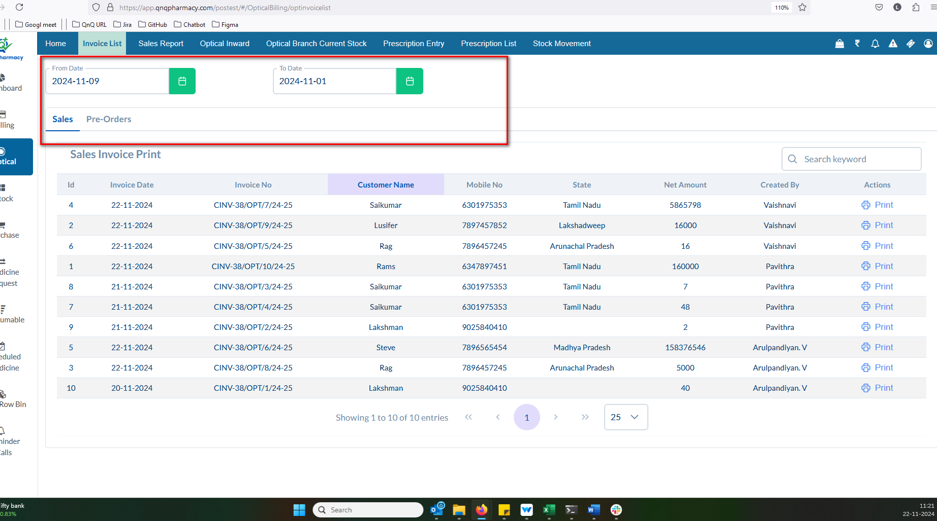 //
3. Download options are displayed even when no values are available in the list grid 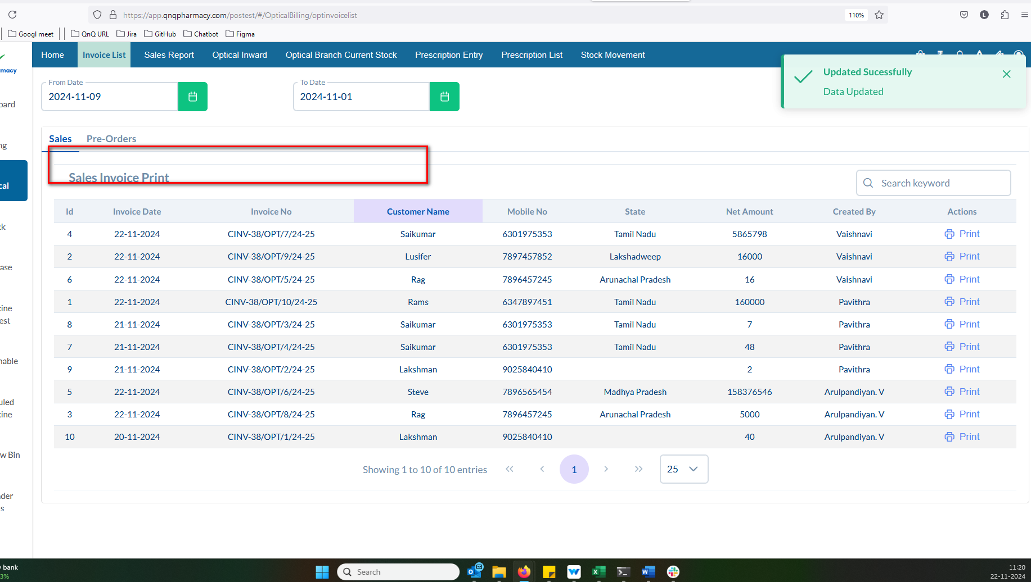 //
4. Error message not display while invalid date range 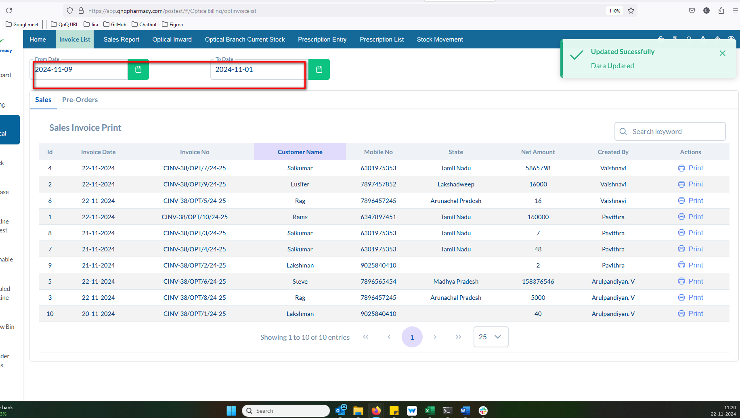 //
5. Success message display mismatch content 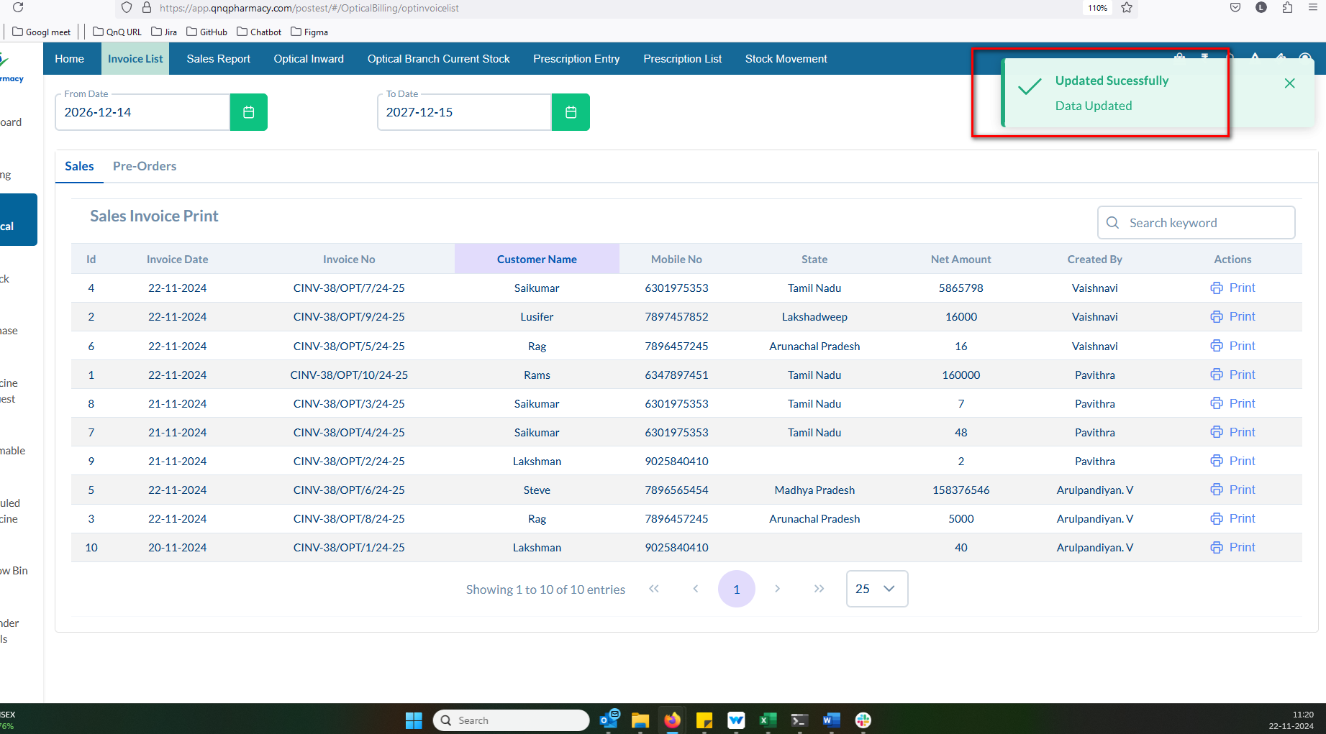 //
6. Error message not display in Date field while give future date 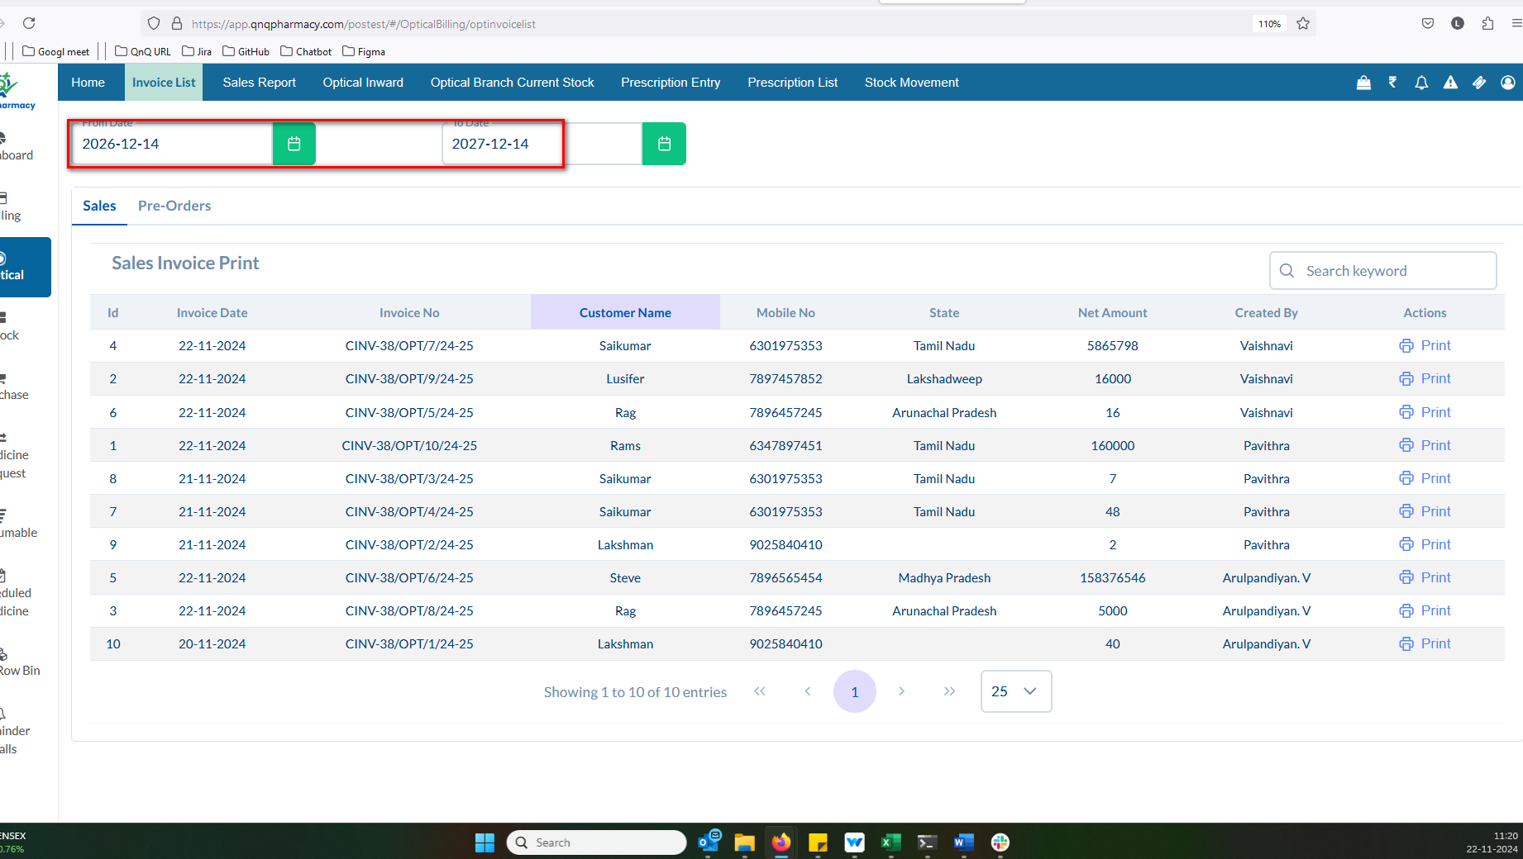 //
7. Refresh icon not available for clear the search filter values 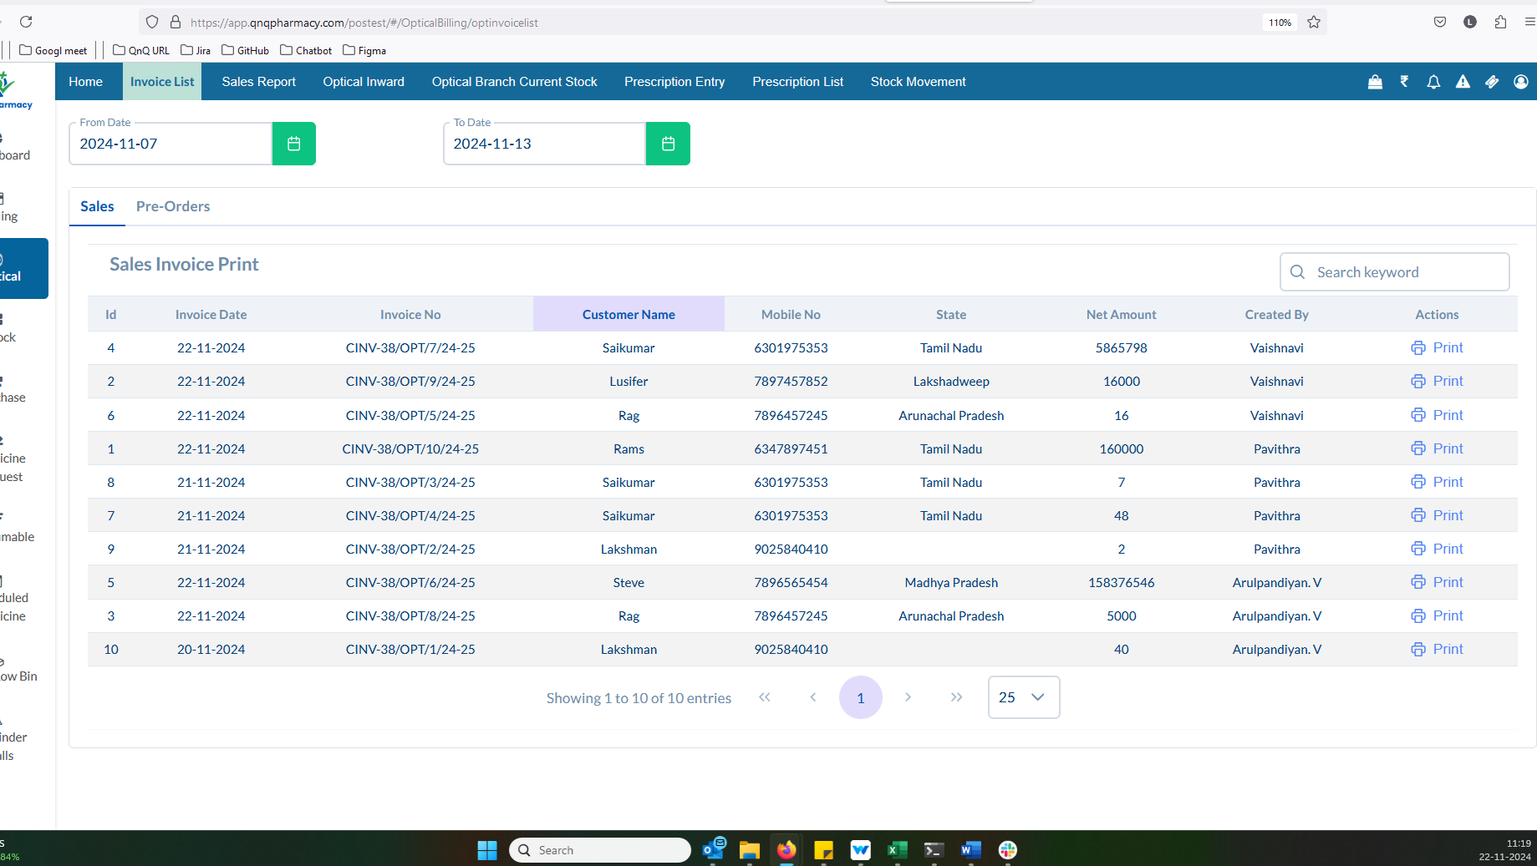 //
8. Mismatch Pop up title display in warning message 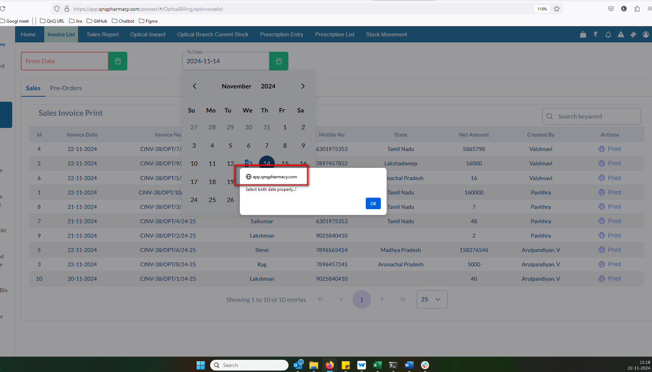 //
9. Mismatch column name display in list grid 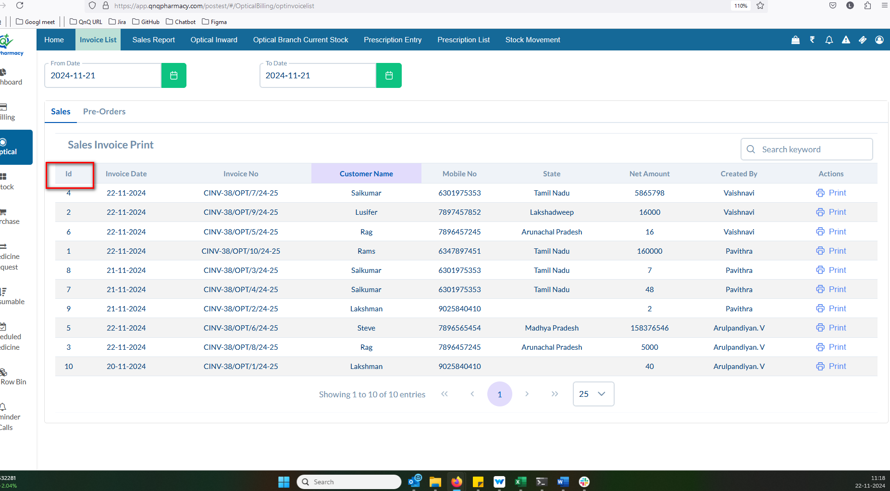 //
10. Invoice list grid not display based on the date range 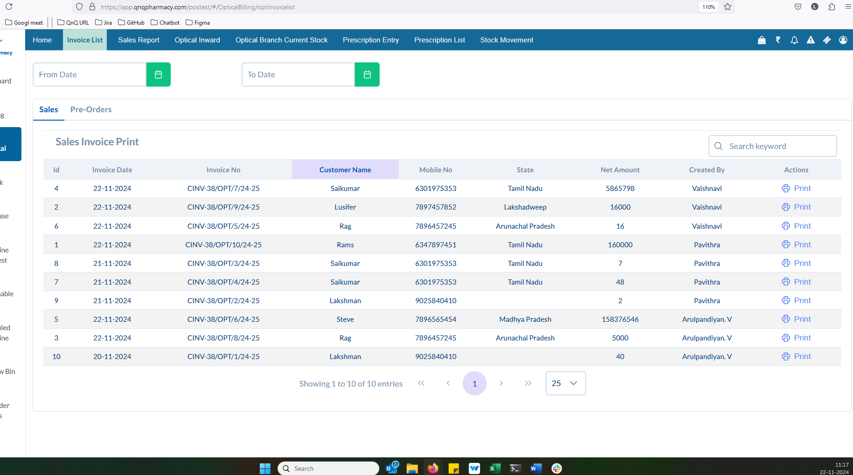 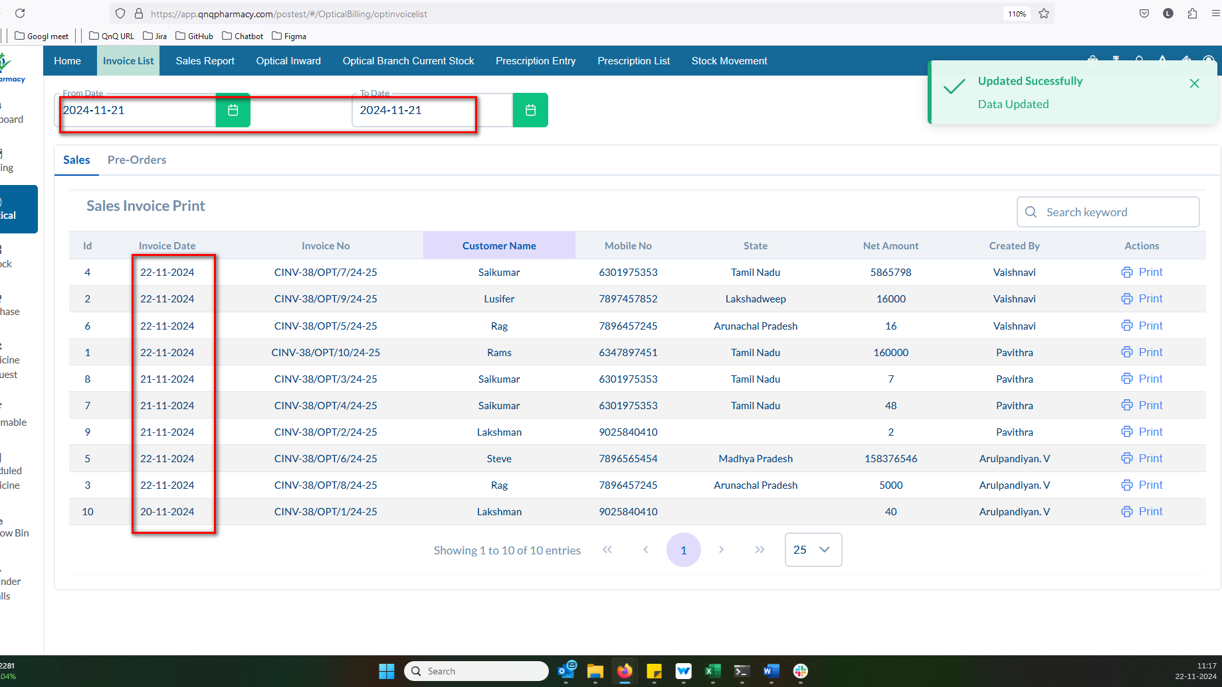 //
11. The sorting feature is not functioning for Customer Name and Net Amount column 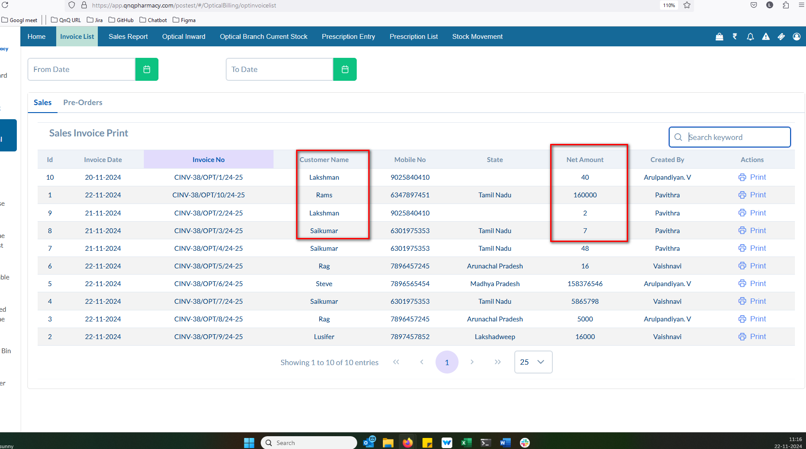 //
12. The column separation line/border is not visible in the Inward list grid 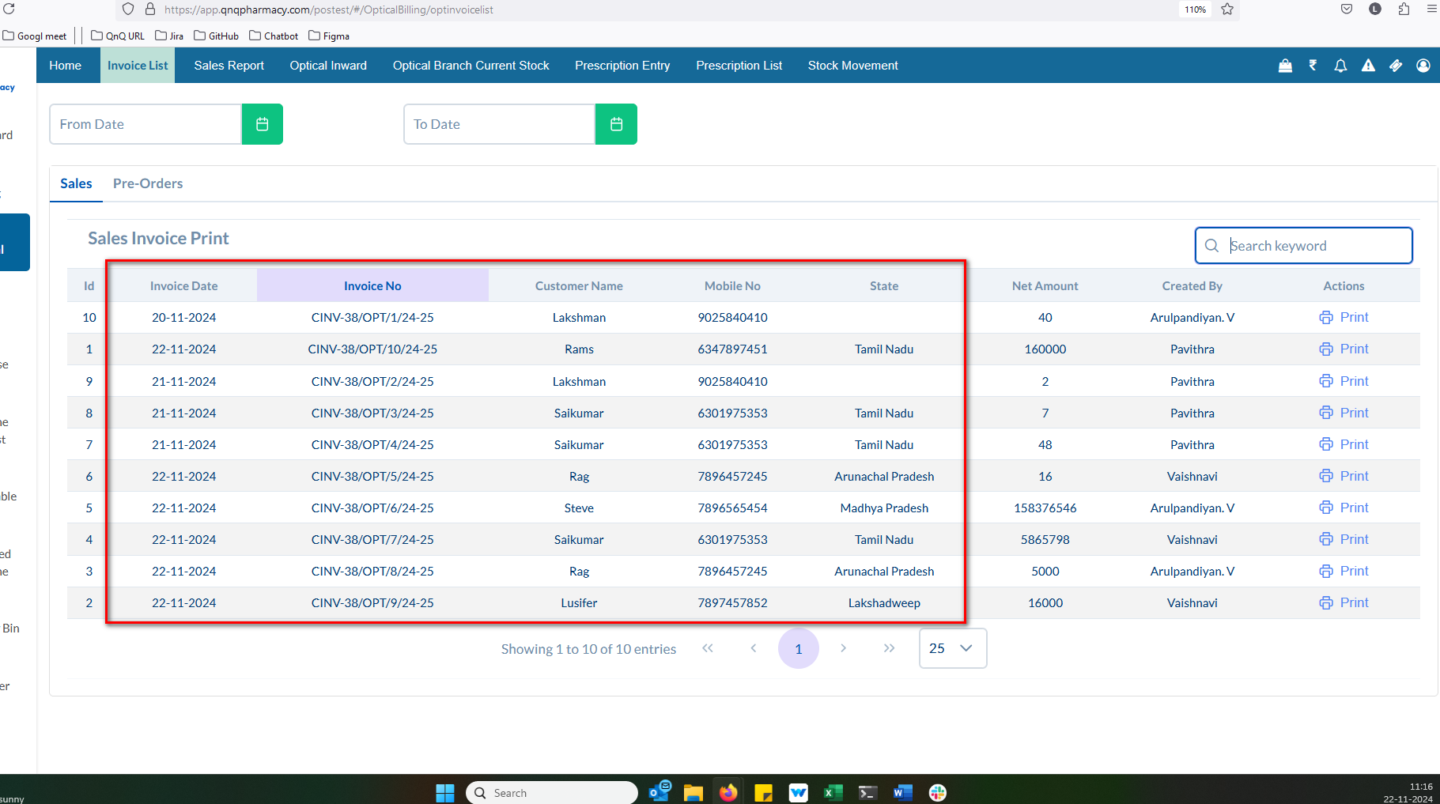 //
13. No record available message not display in list grid 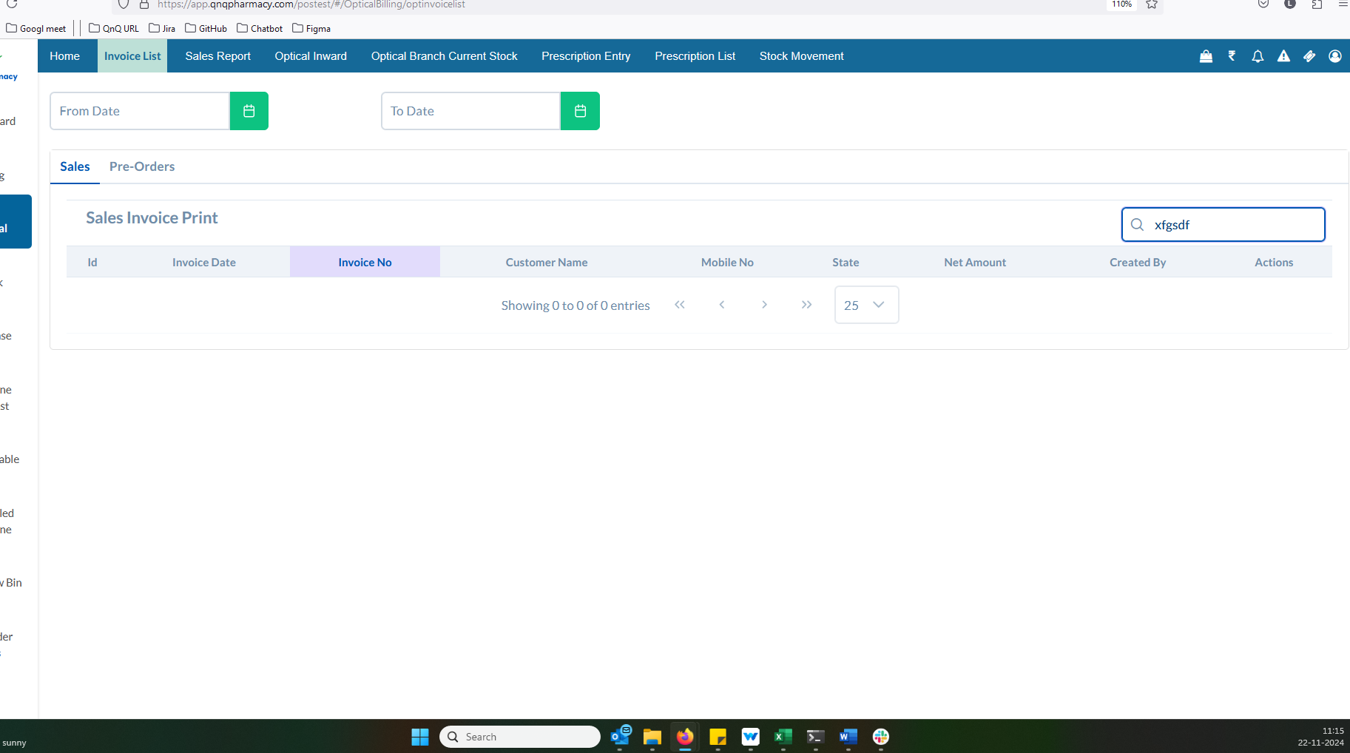 //
14. The pagination controls and count dropdown are positioned in the center of the page 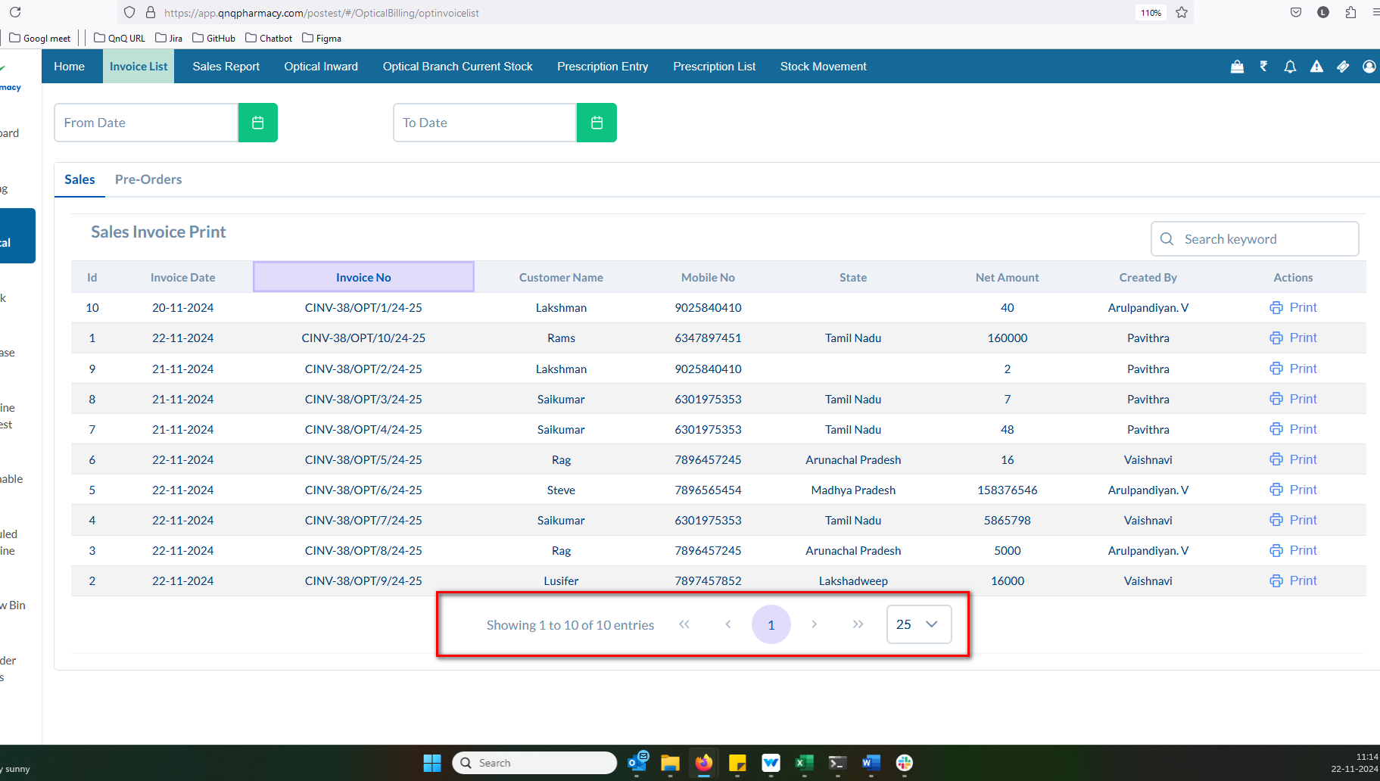 //
15. Unwanted colour display while click column header 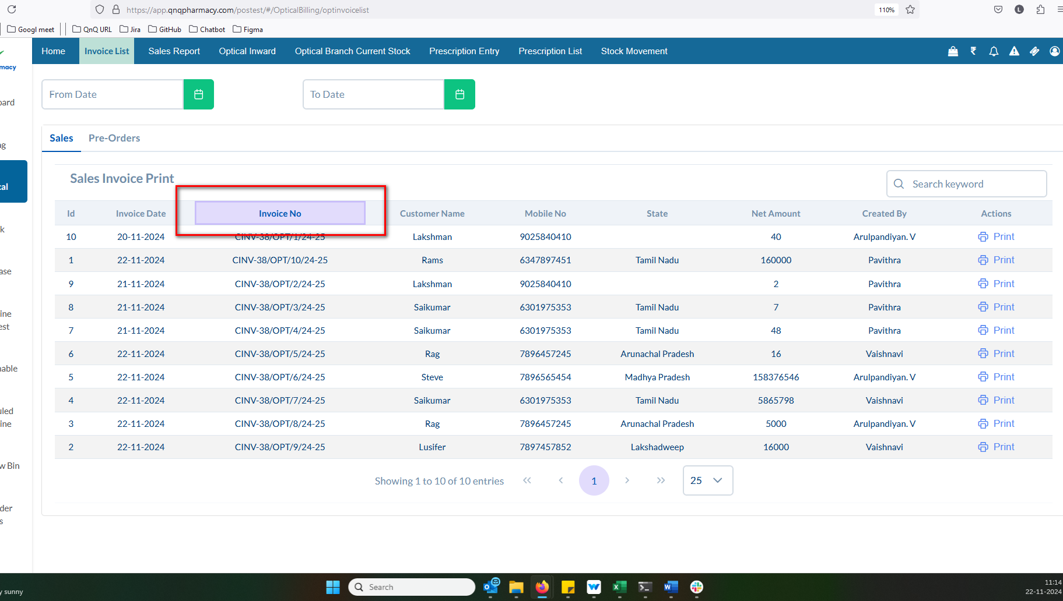 //
16. Sort icon not display in list column 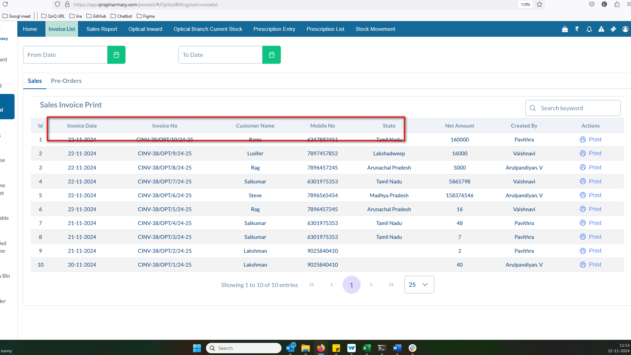 //
17. The amount in words does not reflect Indian Rupees 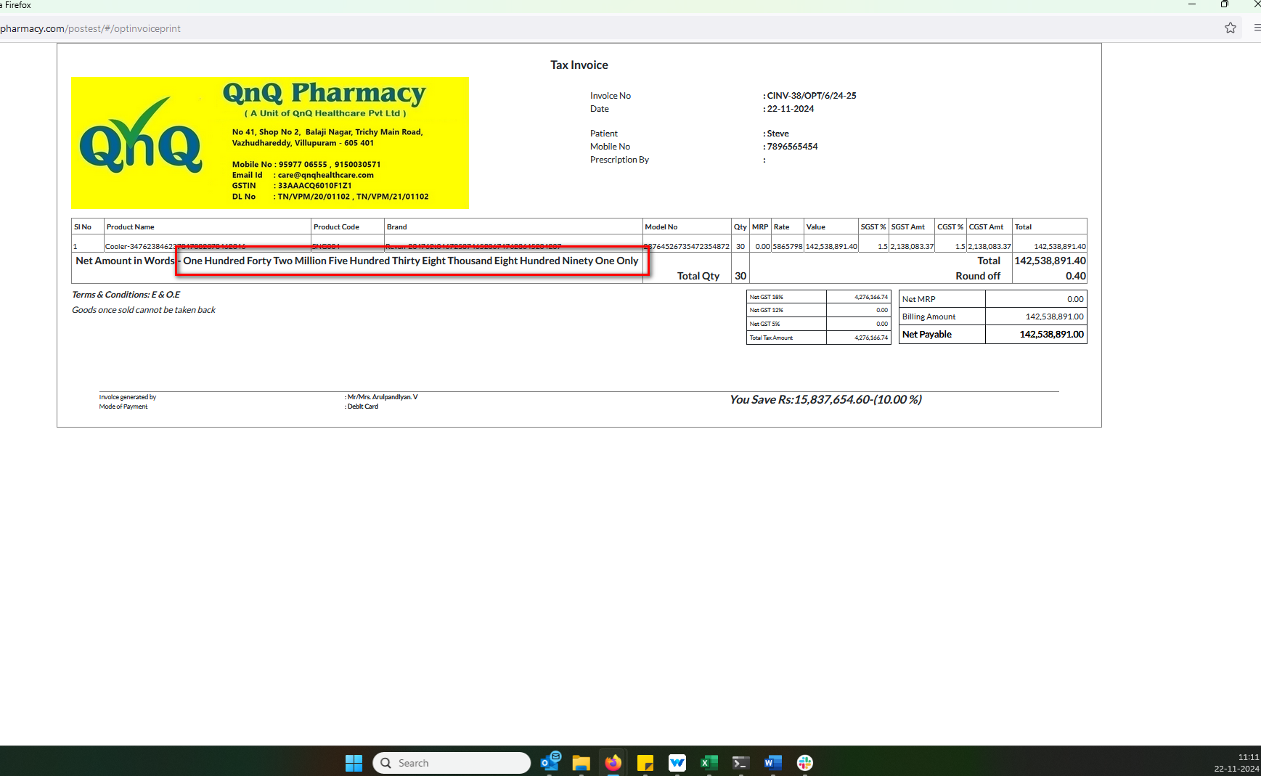 //
18. Unwanted border line display in list grid 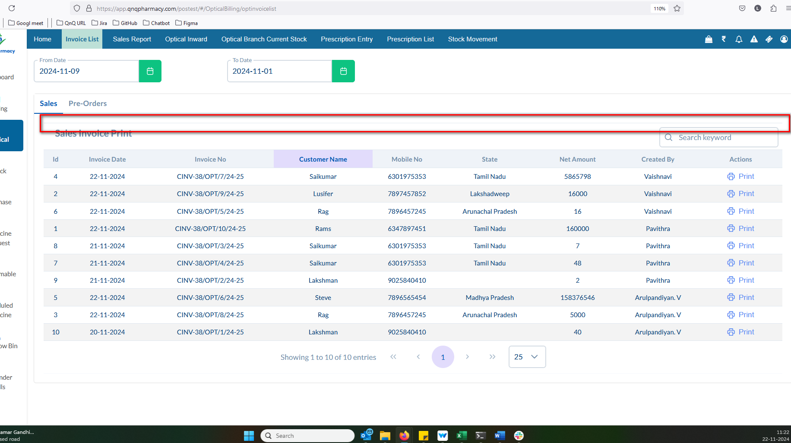 //
19. //
20. //
21. //
22. //
23. //